Complaint Redressal

Flow Diagram

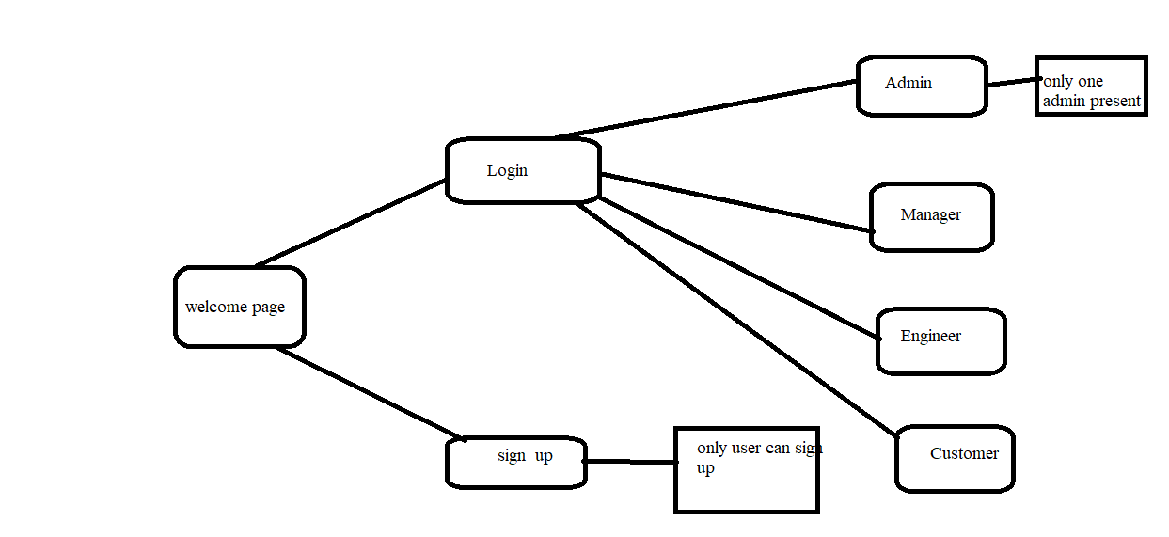

Admin Functionalities:

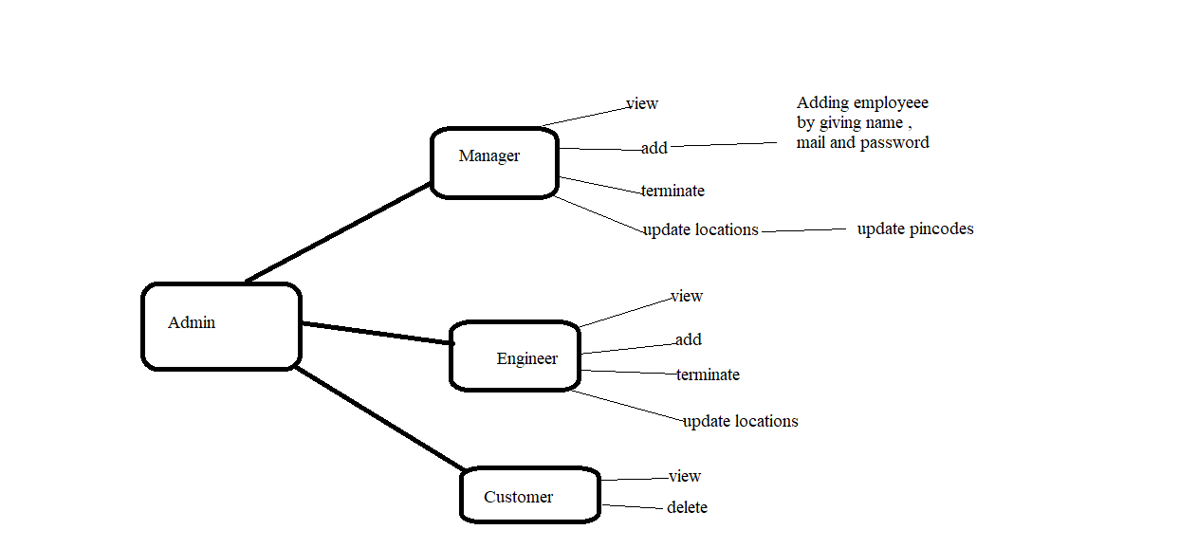

Manager Functionalities :

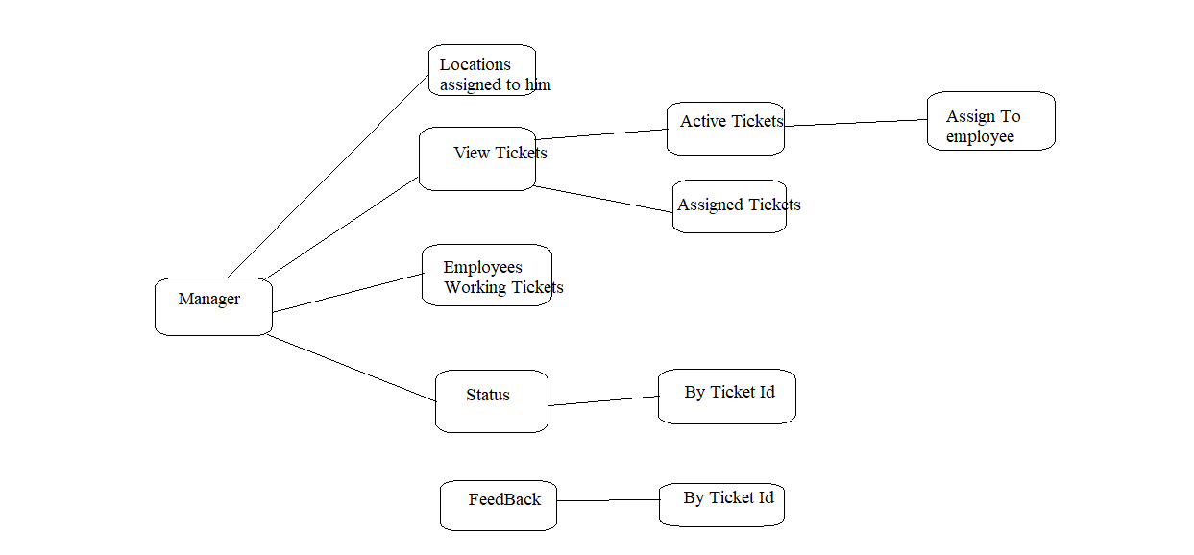

Engineer Functionalities :

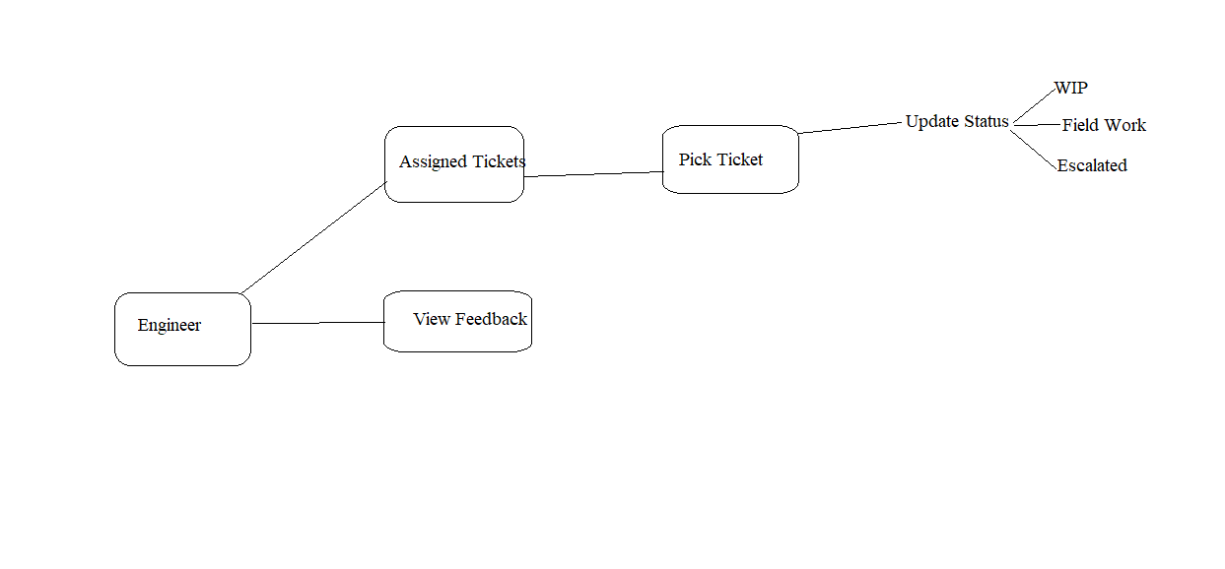

Customer Functionalities :

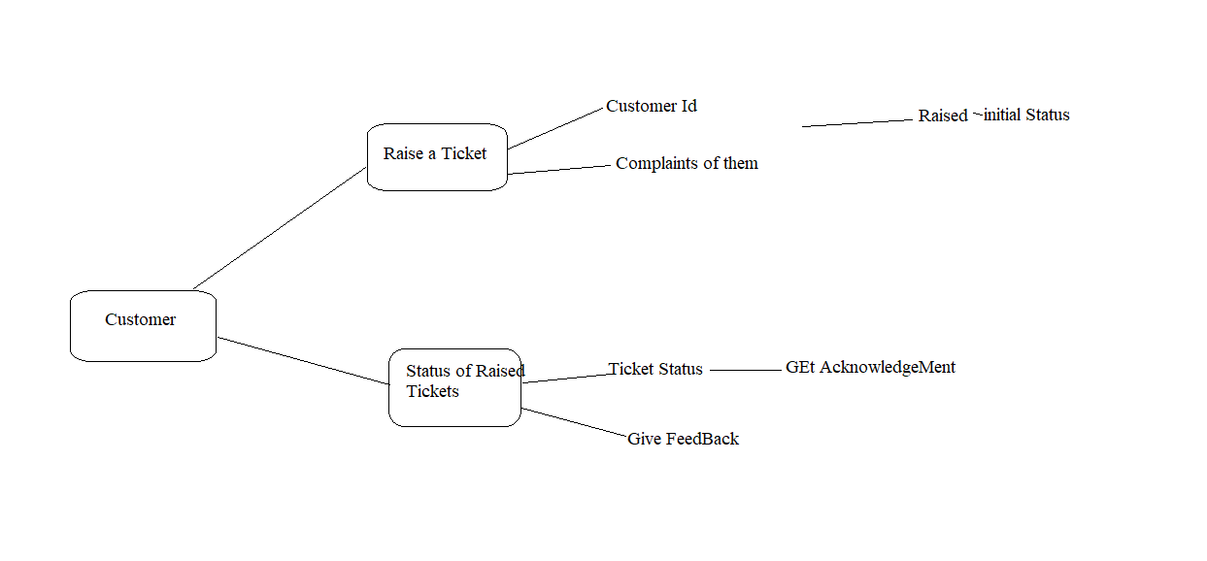

Login Page :

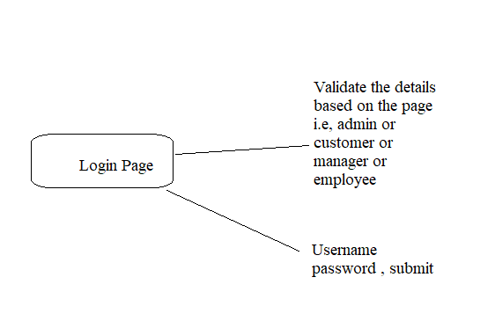

Data Bases Tables :

Customer: cid primary Key auto increment , cname , mobile number, email unique and not null, address d no,city , pin code.

Manager : mid primary key, name , mail.

Engineer : eid primary key, name , mail , pincode (assigned to him/her)

Complaints : Tid primary key, user id , reason, status(rasied,WIP,assigned to field Worker, Resolved and escalated), eid, pin code.

Feedback : tid , feedback of ticket.

Login : username and password and type of user based upon page .

Pin code : pin code, mid;

Login and signup ---🡪 Saveri

Admin --🡪Yuvaraj and Thameem

Manager --🡪Ganesh and vethamathura

Engineer ---🡪Priya and sravan

Customer --🡪 Surya and swetha

Back end

1 . com.telecom

Login :

Com.telecom.login .bean.Login

Com.telecom.login.repository.LoginRepo

Com.telecom.login.service.LoginService

Com.telecom.login.controller.LoginController

Admin :

Com.telecom.admin.bean.Admin

Com.telecom.admin.repository.AdminRepo

Com.telecom.admin.service.AdminService

Com.telecom.admin.controller.AdminController

Manager :

Com.telecom.manager.bean.Manager

Com.telecom.manager.repository.ManagerRepo

Com.telecom.manager.service.ManagerService

Com.telecom.manager.controller.ManagerController

Engineer :

Com.telecom.engineer.bean.Engineer

Com.telecom.engineer.repository.EngineerRepo

Com.telecom.engineer.service.EngineerService

Com.telecom.engineer.controller.EngineerController

Customer :

Com.telecom.customer.bean.Customer

Com.telecom.customer.repository.CustomerRepo

Com.telecom.customer.service.CustomerService

Com.telecom.customer.controller.CustomerController

Front end:

Ng new Complaint-app

componets --🡪 logindashboard

admindashboard

managerdashboard

engineerdashboard

customerdashboard